ADVANCE MATHEMATICAL FUNCTION CALCULATOR

CODE:

#!/usr/bin/python

# -*- coding: utf-8 -*-

# Advanced Mathematical Functions Calculator

# Banking Operations

# This function finds the Annual Percentage Yield

# r is stated annual interest rate

# n is number of times compounded

def APY(r, n):

return 1 + r / n ^ n - 1

# This function gives Debt to Income Ratio

# m is Monthly debt payments

# g is gross monthly income

def DIR(m, g):

return m / g

# This function finds the profit

# s is selling price

# c is cost price

def profit(s, c):

return s - c

# This function finds the loss

def loss(s, c):

return c - s

# This function finds the compound interest

# p is principal amount

# r is rate per period

# n is number of periods

def CI(p, r, n):

return (p(1 + r) ^ n) - 1

# This function finds the simple interest

# p is principal amount

# r is rate per period

# t is time

def SI(p, t, r):

return p * t * r / 100

# Temperature Conversions

# This function converts temperature from celsius to fahrenheit

# c is temperature in celsius

# f is temperature in fahrenheit

# k is temperature in kelvin

def ctof(c):

return c * 9 / 5 + 32

# This function converts temperature from celsius to kelvin

def ctok(c):

return c + 273.15

# This function converts temperature from fahrenheit to celsius

def ftoc(f):

return (f - 32) * 5 / 9

# This function converts temperature from fahrenheit to kelvin

def ftok(f):

return (f - 32) * 5 / 9 + 273.15

# This function converts temperature from kelvin to celsius

def ktoc(k):

return k - 273.15

# This function converts temperature from kelvin to fahrenheit

def ktof(k):

return k - 273.15

# Operations related to measurements

# This function finds area of circle

# r is radius of the circle

def area_circle(r):

return 3.147 * a * a

# This function finds area of square

# x is the one of the side of the square

def area_square(x):

return x * x

# This function finds perimeter of square

# a is side of the square

def peri_square(a):

return 4 * a

# This function finds perimeter of circle

# r is radius of the circle

def peri_circle(r):

return 2 * 3.147 * r

# This function finds area of triangle

# h is height of the triangle

# b is base of the triangle

def area_triangle(h, b):

return h * b / 2

# This function finds area of rectangle

# a is smaller side of rectangle

# b is larger side of rectangle

def area_rectangle(a, b):

return a * b

# This function finds perimeter of rectangle

# l is length of the rectangle

# w is width of the rectangle

def peri_rectangle(l, w):

return 2 * (l + w)

# This function finds perimeter of triangle

# a is first side of the triangle

# b is second side of the triangle

# c is third side of the triangle

def peri_triangle(a, b, c):

return a + b + c

print 'Select operation:'

print '1.APY'

print '2.DIR'

print '3.profit'

print '4.loss'

print '5.CI'

print '6.SI'

print '7.ctof'

print '8.ctok'

print '9.ftoc'

print '10.ftok'

print '11.ktoc'

print '12.ktoc'

print '13.area_circle'

print '14.area_square'

print '15.peri_square'

print '16.peri_circle'

print '17.area_triangle'

print '18.area_rectangle'

print '19.peri_triangle'

print '20.peri_rectangle'

while True:

# Take input from the user

choice = input('Enter choice: ')

# Check if choice is one of the four options

if choice in (

'7',

'8',

'9',

'10',

'11',

'12',

'13',

'14',

'15',

'16',

):

num1 = float(input('Enter first number: '))

if choice == '7':

print ctof(num1)

elif choice == '8':

print ctok(num1)

elif choice == '9':

print ftoc(num1)

elif choice == '10':

print ftok(num1)

elif choice == '11':

print ktoc(num1)

elif choice == '12':

print ktof(num1)

elif choice == '13':

print area_circle(num1)

elif choice == '14':

print area_square(num1)

elif choice == '15':

print peri_square(num1)

elif choice == '16':

print peri_circle(num1)

break

elif choice in (

'1',

'2',

'3',

'4',

'17',

'18',

'20',

):

num1 = float(input('Enter first number: '))

num2 = float(input('Enter second number: '))

if choice == '1':

print APY(num1, num2)

elif choice == '2':

print DIR(num1, num2)

elif choice == '3':

print profit(num1, num2)

elif choice == '4':

print loss(num1, num2)

elif choice == '17':

print area_triangle(num1, num2)

elif choice == '18':

print area_rectangle(num1, num2)

elif choice == '20':

print peri_rectangle(num1, num2)

break

elif choice in ('5', '6', '19'):

num1 = float(input('Enter first number: '))

num2 = float(input('Enter second number: '))

num3 = float(input('Enter third number: '))

if choice == '5':

print CI(num1, num2, num3)

elif choice == '6':

print SI(num1, num2, num3)

elif choice == '19':

print peri_triangle(num1, num2, num3)

break

else:

print 'Invalid Input'

PEP8 ONLINE CHECK:

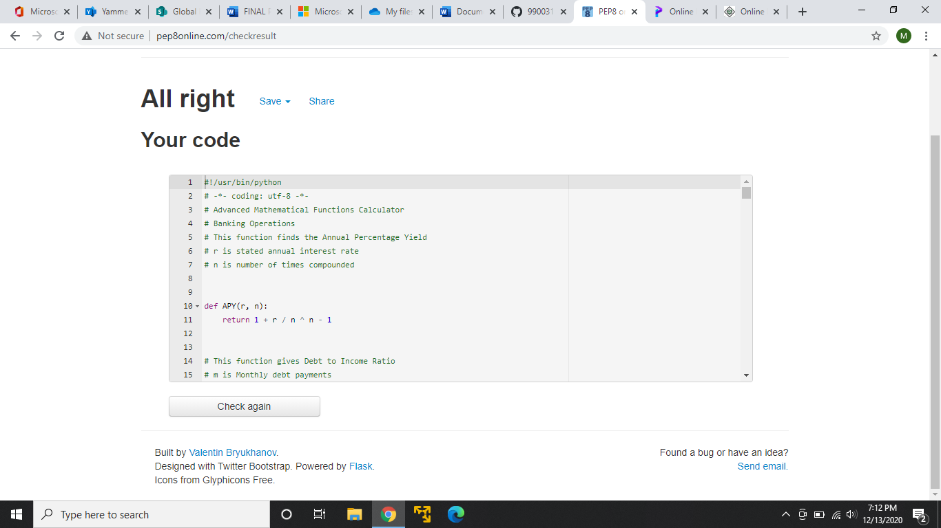

GITHUB LINK: https://github.com/99003154/Python.Mini